Post-Treated Spent Bleaching Earth (PSBE) as Cementitious Material

j,x,y,z,a  
*Civil Engineering Department, Institut Teknologi Sepuluh Nopember Surabaya (ITS)*  
*e-mail*: jevon080101@outlook.com

*Abstract*—PSBE, which stands for post-treated spent bleaching earth, is a term used to describe SBE (Spent Bleaching Earth) that has undergone a specific type of treatment. The purpose of the treatment is to remove the oil content from the SBE, and there are several methods available for achieving this.

In this paper, we will be using acetone as the solvent agent to treat SBE. Acetone is a commonly used solvent that is highly effective in removing oil from various materials. We will compare the resulting PSBE with PCC (Portland cement concrete) as the workbench standard and fly ash, which is the most commonly used substitute for cement in concrete production.

The comparison will be based on various properties such as strength, durability, and workability. By comparing the properties of PSBE with those of PCC and fly ash, we could determine the feasibility of using PSBE as a substitute for cement.

*Keywords*—Acetone, Comparison, Fly ash, PCC, PSBE, SBE, Treatment

# INTRODUCTION

S

pent bleaching earth or fuller’s earth is a waste from oil and fat industry. SBE is primarily composed of clay minerals, such as Illite, Kaolinite, and organic matter, including residual oil and various impurities [1]. SBE is generated during the oil refinement procedure. As such, it is necessary to first remove the oil from SBE.

There are many attempts in removing PSBE’s oil content. Some uses extraction [2] while some uses heat regeneration [3]. This research would lean toward the former as the later would cause CO2 emission, which is opposed to the research goal itself.

The chemical used for extraction can be either a polar or non-polar solvent [4]. However, when using an alcohol-based solvent like methanol, heat regeneration is required to remove any remaining toxic substances [5]. But more often than not, extraction followed by heat regeneration would be more efficient than simply using solvent extraction [1].

In this research, acetone would be utilized as the solvent agent. Acetone is a widely used solvent known for its effectiveness in removing [6]. Acetone’s unique property enables it to function as both polar and nonpolar solvent [7]. Additionally, acetone is readily available and more cost-effective compared to alternative solvents like n-hexane and benzene.

This research focused on the solvent extraction procedure by identifying the variables related to the extraction. Therefore, it aims to provide a recommendation on the most effective treatment method to be used. Since the aim of this experiment is to evaluate the potential of post-treated spent bleaching earth (PSBE) as a sustainable cement substitute. The properties of PSBE would be compared with two other common cementitious materials: fly ash and Portland Composite Cement (PCC).

We would be making two types of samples: cement pastes and mortars. Cement paste could be used to assess early behavior of the cementitious materials, such as its setting time and strength. On the other hand, mortar could be used to assess and evaluate the cementitious material properties, such as its hydration heat rate and workability.

In summary, our experiment involves making and testing cement paste and mortar samples using PSBE, fly ash, and PCC as cementitious materials. By conducting tests on these samples, we would be able to compare and evaluate PSBE’s properties against other materials.

# RESEARCH METHODOLOGY

## PSBE Treatment Variation

The first thing ought to be checked is the optimum acetone ratio. We need to know the effects of different acetone ratios on SBE. Additionally, we should investigate whether different SBE quantities (with the same SBE: Acetone ratio) affect PSBE’s oil content. Figure 1 contains a brief linked diagram that briefly illustrates the variations involved:

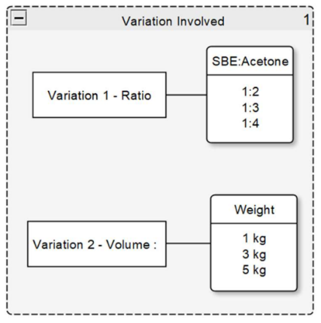

Figure 1. SBE treatment variation

The treatment itself would involve two variables (Figure 1): the SBE to acetone ratio and the volume of SBE. Adding 1 kg is equivalent to adding 2 liters of acetone. In total, we would have 9 different variations resulting from the different combinations.

To ensure that the most suitable variation is chosen, we would consider two critical factors: the oil content percentage and the acetone ratio. Since our main goal is to reduce the oil content of the SBE, the oil content percentage will be the main consideration. However, the acetone ratio would also be another consideration as the amount of acetone used would be impacting the economic side of things.

## PSBE treatment method

The treatment process begins by measuring the SBE to acetone ratio. For each kilogram of SBE, we’d add one liter of acetone (the specific ratios used are listed in Figure 1).

Next, we would mix SBE and acetone thoroughly for 30 minutes, with 15 minutes at a slow speed followed by another 15 at a medium speed. We’d then allow the mixture to rest for 24 hours at a moderate temperature.

After 24 hours, we would separate the SBE from the acetone and allow the remaining SBE to dry in the open air until it is no longer damp (the drying time may vary each day). The acetone would be discarded as recycling acetone is not part of this research. Once the SBE is dry, we would place it in the oven for an additional 24 hours to ensure that all moisture has been removed. The resulting PSBE would then be stored in a zip lock bag to prevent moisture absorption. We would then take a 100-grams sample to measure its oil content.

In summary, the treatment process involves measuring SBE to acetone ratio, mixing SBE and acetone thoroughly, allowing the mixture to rest, separating SBE from acetone, drying the SBE, and finally storing the resulting PSBE. The 100-gram sample is then taken for oil content analysis.

## Cement Paste Variation

There are a total of three materials that we need to compare: PCC, fly ash, and PSBE. We have decided that both fly ash and PSBE would replace 5%, 10%, and 15% of the PCC used. This variation is summarized in Figure 2. Table 2 contains the tabulated version of Figure 2

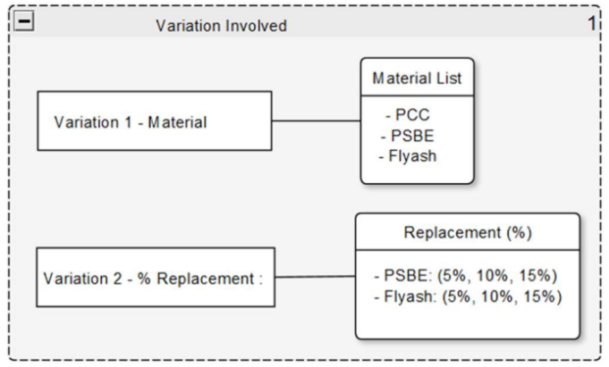

Figure 2. Cement paste variation

Table 1. Cement paste replacement quantity

|  |  |  |
| --- | --- | --- |
| **Sample Name** | **Material replacement quantity (gr)** | |
| **PCC** | **Substituent** |
| PCC | 300 | 0 |
| PSBE_5 | 285 | 15 |
| PSBE_10 | 270 | 30 |
| PSBE_15 | 255 | 45 |
| FA_5 | 285 | 15 |
| FA_10 | 270 | 30 |
| FA_15 | 255 | 45 |
| SBE_5 | 285 | 15 |
| SBE_10 | 270 | 30 |
| SBE_15 | 255 | 45 |

The reason for only replacing a small portion of PCC with substitute materials such as fly ash and PSBE is because PCC already contains pozzolanic materials. Therefore, there is no need to add another excessive amount of substitute material. This replacement process is done to optimize the performance of the cement paste (using smaller percentage of substitution material would definitely help).

On the 28th day, the compression test would be conducted. Additionally, a fraction of the cement paste’s fragments will be used as the XRD and SEM-EDX sample.

## Mortar Variations

The material variation in the mortar would be the same as that in the cement paste. In addition to material variation, the mortar(s) will also have age as the variable. The mortar samples will be tested at four different ages: 3, 7, 14, and 28 days. This allows one to evaluate the effects of both the material variation and the age. The variation involved is summarized by Figure 3:

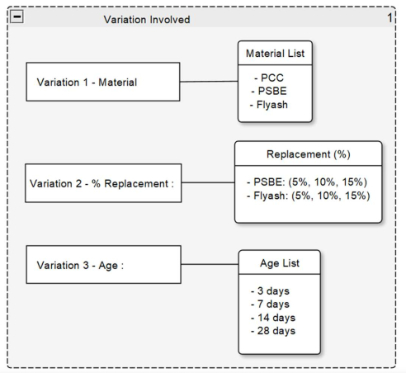

Figure 3. Mortar variations

Table 2. Mortar material composition

|  |  |  |  |  |
| --- | --- | --- | --- | --- |
| **Sample Name** | **Cement weight (gr)** | | **Water quantity (ml)** | **Sand quantity (gr)** |
| **PCC** | **Substituent** |
| PCC | 500 | 0 | 242 | 1375 |
| PSBE_5 | 475 | 25 | 242 | 1375 |
| PSBE_10 | 450 | 50 | 242 | 1375 |
| PSBE_15 | 425 | 75 | 242 | 1375 |
| FA_5 | 475 | 25 | 242 | 1375 |
| FA_10 | 450 | 50 | 242 | 1375 |
| FA_15 | 425 | 75 | 242 | 1375 |
| SBE_5 | 475 | 25 | 242 | 1375 |
| SBE_10 | 450 | 50 | 242 | 1375 |
| SBE_15 | 425 | 75 | 242 | 1375 |

# RESULT AND ANALYSIS

## PSBE Oil Content

The oil content result of PSBE is presented by Figure 4 and Table 1.

Table 3. Oil content analysis result (%)

| **PSBE Quantity** | **SBE: Acetone** | | |
| --- | --- | --- | --- |
| **1:2** | **1:3** | **1:4** |
| **1 kg** | 1.1109 | 1.0163 | 1.3061 |
| **3 kg** | 0.9892 | 0.8357 | 0.8289 |
| **5 kg** | 1.1977 | 0.9099 | 0.6776 |

Figure 4. Oil content test result

The overall result confirms that acetone could be used to remove SBE oil effectively. This alligns with Zahrani & Daous [2] research, in which acetone was able to remove 80.8% of SBE oil content.

After analyzing Table 1, it is evident that there is no clear corellation between SBE quantity and its oil percentage. For example, the oil content of 1 kg with a 1:2 ratio is not significantly different from the 3 kg with the same ratio.

Similarly, Figure 4 shows that there is no clear pattern that links PSBE oil content with SBE:Acetone ratio. This lack of correlation indicates that PSBE’s oil content is not directly related to the SBE:acetone ratio.

Based on these observations, we have decided to use 5 kg of PSBE with the 1:2 ratio to produce both cement pastes and mortars. This decision was based on several factors.

First, it was observed that the oil content doesn’t vary (significantly) with the quantity of PSBE used. This indicates that using a larger quantity of PSBE would not have a large impact on the resulting product.

Secondly, there’s no clear pattern linking PSBE oil content to SBE:acetone ratio. This indicates that the oil content is not strongly influenced by SBE:acetone ratio, and thus, using a lower SBE:acetone ratio would not necessarily result in a lower oil content.

At last, the decision to use the largest quantity of PSBE with the lowest amount of SBE:acetone ratio was based on the practicality and economic factors. Using a larger quantity of PSBE with the lowest SBE:acetone ratio would simplify the manufacturing process and reduce the overall production costs.

## PSBE Setting Time

The setting time experiment (ASTM C191) is carried out between PCC, PSBE, and fly ash. The resulting setting time regression is shown in Figure 5, and the corresponding data will be presented in Table 4. The material used for production can be observed in Table 1 and the water ratio is obtained from the normal consistency test result (available on Section D).

Table 4. Setting time data

|  |  |  |
| --- | --- | --- |
| **Sample Name** | **Initial Setting Time (min)** | **Final Setting Time (min)** |
| PCC | 102 | 208 |
| PSBE_5 | 74 | 209 |
| PSBE_10 | 105 | 241 |
| PSBE_15 | 102 | 277 |
| Flyash_5 | 87 | 249 |
| Flyash_10 | 110 | 268 |
| Flyash_15 | 119 | 294 |

Figure 5. Setting time comparison chart

Since much research related to fly ash has been conducted, we can confirm the testing results by comparing them with the findings of another study. Upon examining the results of Marta Kosior-Kazberuk and Małgorzata Lelusz research [8], which investigated the effects of adding varying quantities of fly ash to cement paste, it is evident that the addition of fly ash would prolong both paste’s initial and final setting time. This prolong effect is due to the pozzolanic reaction, which would form Toberimite gel that’ll delay the main cement hydration process [9].

PSBE would also result in prolonged setting time, primarily due to the presence of the Illite component, as revealed by XRD testing. This information is presented in Table 5.

Table 5. XRD Testing Result (Dominant Element)

|  |  |  |  |
| --- | --- | --- | --- |
| **Crystallin Name** | **Chemical Formula** | **PSBE (%)** | **SBE (%)** |
| Quartz | SiO2 | 6.85 | 5.83 |
| Calcite | CaCO3 | 3.58 | 4.52 |
| Cristobalite low | SiO2 | 3.04 | 0.19 |
| Illite | Al4KO12Si2 | 15.07 | 8.74 |
| Natron (Soda) | Na2CO3.10H2O | 2.24 | 2.33 |
| Sodalite | Na8Al6Si6O24BF42 | 12.2 | 3.7 |
| Sanidine Na0.1 | Na0.1K0.83AlSi3O8 | 2.32 | 1.14 |
| Orthoclase | KAlSi3O8 | 2.05 | 0.21 |
| Tridymite orthorhombic | SiO2 | 2.73 | 1.84 |
| Gaylussite | Na2Ca (CO3)2H2)5 | 3.09 | 0.72 |

Illite is a material commonly found in clay or clayey soils. Illite has a two-layer structure or a double structure that "allows" water to enter between the gaps of the two layers [7]. In addition, the Illite component is found in bentonite and plays a role in facilitating the consolidation, swelling, and expansion of bentonite, although Illite itself does not cause the expansion of bentonite. This property can disrupt the cement-hydration reaction, as it necessitates sufficient water to react with the cement.

## XRF analysis

XRF analysis, which stands for X-ray fluorescence analysis, is a technique used to determine the elemental composition of a material properties. In this experiment, it is used to classify fly ash and PSBE based on the chemical requirements outlined in Table 1 of ASTM C618.

Table 6 contains the chemical properties stated by ASTM C618, while Table 7 contain the summation of Table 6’s component.

Table 6. Main Components in XRF analysis Result

|  |  |  |
| --- | --- | --- |
| **Components** | **Percentage** | |
| **PSBE** | **Fly ash** |
| Al2O3 | 4 | 7.4 |
| SiO2 | 38 | 20.5 |
| Fe2O3 | 26.7 | 36.95 |
| SO3 | 1.4 | 2.2 |

Table 7. Components Grouping (ASTM C618)

|  |  |  |  |
| --- | --- | --- | --- |
| **Total  (% Al2O3+SiO2+Fe2O3)** | | **Total  (% SO3)** | |
| **PSBE** | **Fly ash** | **PSBE** | **Fly ash** |
| 68.7 | 64.85 | 1.4 | 2.2 |
|
|
|

Based on the chemical components listed in Table 7, it can be concluded that both PSBE and fly ash belongs to the C class category as defined in ASTM C618’s Table 1.

## Normal Consistency

This test is done based on C187. Normal consistency is presented in Figure 6, while the corresponding data would be listed in Table 5.

Figure 6. Normal Consistency Result

Table 8. Water test consistency result

|  |  |  |
| --- | --- | --- |
| **Sample Name** | **Water (ml)** | **w/c (%)** |
| PCC | 79 | 26.33 |
| PSBE_5 | 81 | 27 |
| PSBE_10 | 93 | 31 |
| PSBE_15 | 97 | 32.33 |
| FA_5 | 78 | 26 |
| FA_10 | 76 | 25.33 |
| FA_15 | 77 | 25.67 |
| SBE_5 | 87 | 29 |
| SBE_10 | 94 | 31.33 |
| SBE_15 | 100 | 33.33 |

The resulting water to cement ratio would be used to make cement paste admixture.

By examining the results of Murkajee [10], who investigated the effects of using different percentages of fly ash (0-70%) as a cement substitute, we can confirm that the addition of fly ash reduces the amount of required water.

After analyzing Figure 6, it can be inferred that both SBE and PSBE require a larger amount of water to reach normal consistency compared to PCC and fly ash.

## Passing Sieve Analysis

Passing sieve analysis is done based on ASTM C430. Passing sieve analysis result could be seen in Figure 7 and its corresponding value could be seen in Table 6.

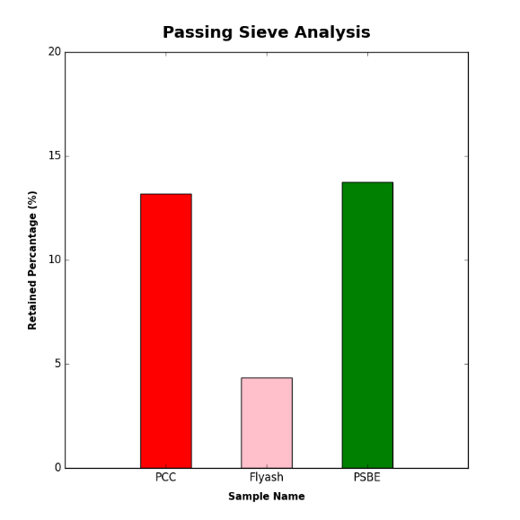

Figure 7. Comparison of retained material

Table 9. Passing sieve analysis result

|  |  |  |  |  |
| --- | --- | --- | --- | --- |
| **Name** | **Retained Weight (gr)** | **Passing Sieve (gr)** | **Total Weight (gr)** | **Retained (%)** |
| PCC | 13.2 | 86.8 | 100 | 13.2 |
| Fly ash | 4.33 | 95.67 | 100 | 4.33 |
| PSBE | 13.73 | 86.2 | 99.93 | 13.74 |

Figure 7 clearly illustrates that PSBE has the highest retained weight percentage, followed by PCC and fly ash. The difference of the retained weight percentage between PSBE and PCC passing sieve result, when compared to fly ash’s, is significantly larger.

However, it should be noted that all three materials meet the requirements set by SNI 15-2500-2004, which stipulates that the retained percentage of cementitious materials should not exceed 24%. Therefore, despite the significant difference between PSBE, PCC, and fly ash passing sieve results, they all satisfy the standard requirement.

## Cement Paste Compression Test

Cement paste compression test result is displayed in Figure 8 and its corresponding value could be seen in Table 10.

Figure 8. Paste Compression Strength

Table 10. Paste compression strength data

|  |  |
| --- | --- |
| **Sample Name** | **Compression Strength (MPa)** |
| PCC | 61.77 |
| PSBE_5 | 50.93 |
| PSBE_10 | 43.16 |
| PSBE_15 | 41.7 |
| FA_5 | 59.1 |
| FA_10 | 58.22 |
| FA_15 | 43.86 |
| SBE_5 | 34.41 |
| SBE_10 | 25.05 |
| SBE_15 | 13.98 |

The data presented in Figure 8 and Table 7 show that the strength of cement paste decreases with the addition of substitute materials. Specifically, the SBE material, which contains oil, displays the lowest strength compared to the other two. However, usage of PSBE, which has had most of its oil content removed, results in consistently better strength than SBE. This again shows the importance of SBE treatment as it the effects of oil would worsen the initial hydration blockage caused by the Illite content found in both SBE and PSBE.

Moreover, it is found that the addition of fly ash also leads to compression strength decrease, although not as significant as in the case of SBE and PSBE.

Overall, these findings suggest that the use of substitute materials has a negative impact on the cement paste. The tendency of fly ash in these results is confirmed by examining the findings of Shaswata Mukherjee, Saroj Mandal, and Adhikari.U.B [10], where an increase in the percentage of fly ash as a cement substitute resulted in a lower tendency of the cement paste.

However, the severity depends on the specific material type and quantity being used. Regardless, all materials exhibit the same tendency: the more cement is substituted, the weaker the cement paste becomes.

## Microstructural Analysis

Microscopy with Energy Dispersive X-ray Spectroscopy (SEM-EDX) techniques would be used to identify the chemical components and elemental composition. Meanwhile, XRD would be utilized to determine the crystalline structure of the material. By combining the data obtained from both techniques, the material’s crystal structure and chemical composition can be identified more accurately.

The initial step of the analysis is to identify the dominant elements present in PSBE. This element would then be matched with the compound found with XRD testing. The SEM-EDX crystalline is shown in Figure 9, while the analysis results would be presented in Table 8.

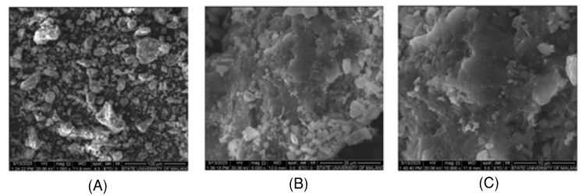

Figure 9. PSBE SEM imagery: (A) 1000x, (B) 5000x, (C) 10000x

Table 11. Match between PSBE’s SEM-EDX and XRD testing result

|  |  |  |
| --- | --- | --- |
| **Sample** | **Dominant Element (SEM-EDX)** | **XRD Crystallin** |
| PSBE | * C (38.6%) * O (50.1%) * Al (1.8%) * Si (6.3%) * K (0.4%) * Ca (0.3%) | Al4KO12Si2 (15.07%)  CaCO3 (3.58%) |

Upon examining Table 8, it becomes evident that Illite (Al4KO12Si2) is the predominant chemical component in both SBE and PSBE samples.

Illite is a type of clay mineral that is known for its distinctive bilayer structure, which allows it to absorb water. This property of Illite could elucidate the reason for the increased water requirement to achieve normal consistency and the longer setting time observed in both SBE and PSBE.

The next thing that would be brought is the XRD and SEM-EDX of the cement paste’s fraction. The result of this correlation could be seen in Table 9.

Table 12. Match between cement paste's XRD and SEM-EDX result

|  |  |  |
| --- | --- | --- |
| **Sample** | **Dominant Element (SEM-EDX)** | **XRD Crystallin** |
| PCC | * C (10.7%) * O (50.6%) * Ca (29.0%) * Si (5.2%) | CaCO3 (12.87%)  SiO2 (0.72%) |
| PSBE_5 | * C (15.4%) * O (56.1%) * Ca (24.1%) * Si (3.0%) | CaCO3 (11.20%)  SiO2 (1.07%) |
| Fly ash_15 | * C (10.5%) * O (50.1%) * Ca (22.9%) * Si (7.1%) | CaCO3 (10.68%)  SiO2 (0.52%) |

Upon examining the chemical composition of the samples, it was evident that Calcite (CaCO3) and Quartz (SiO2) are the two most predominant elements present in all three samples. This data also suggests that there’s little difference detected between the three different samples.

## Mortar Flow

Mortar flow test is done based on ASTM C1437. The mortar flow regression is presented in Figure 10 and Its table is presented in Table 13.

Table 13. Flow mortar test result

| **Sample** | **No. 1 (cm)** | **No. 2 (cm)** | **No. 3 (cm)** | **No. 4 (cm)** | **Avg (cm)** |
| --- | --- | --- | --- | --- | --- |
| PPC | 12 | 11.5 | 11 | 12 | 11.63 |
| PSBE 5% | 12 | 12.5 | 12.5 | 11 | 12 |
| PSBE 10% | 11.5 | 11.2 | 11 | 11 | 11.18 |
| PSBE 15% | 9.5 | 9.5 | 10 | 9.5 | 9.63 |
| Fly ash 5% | 11.5 | 11.5 | 12 | 11.5 | 11.63 |
| Fly ash 10% | 12 | 11.5 | 12 | 11.5 | 11.75 |
| Fly ash 15% | 13 | 12 | 13 | 12 | 12.5 |

Figure 10. Mortar Flow Regression

Based on the data presented in Figure 10 and Table 10, it can be deduced that the addition of PSBE to the mortar mixture would results in the decrease of the mortar flow. This decrease in mortar flow is an indication of reduced workability of the mortar.

This decrease might be caused by the Illite substance (Al4KO12Si2), which is a major component found in the PSBE. Meanwhile, the addition of fly ash to the mortar has a positive effect on the workability of the mixture.

The fly ash particles are finer than both PSBE and PCC, which aids in filling the voids in the mortar mixture. Consequently, this leads to increased workability.

This result is supported by the findings of Antoni’s research [11], where the diameter of flow increased with the addition of fly ash. Furthermore, there seems to be some correlation between mortar flow with paste’s normal consistency. This correlation is emphasized by Figure 11.

Figure 11. Mortar Flow & Normal Consistency

By looking at the tendency shown in Figure 11, It is evident that it is evident that mortar flow serves as a reliable indicator for determining the tendency of normal consistency results. This is particularly apparent in the case of PSBE where reduction of mortar flow would mean more water is need to achieve the required range.

## Mortar Hydration Heat

The mortar hydration heat could be seen Figure 12. This figure contains the recorded temperature.

Figure 12. Recorded Hydration Temperature

Figure 12 clearly illustrates that each sample in the experiment begins at a different initial temperature. This variation in starting temperatures is primarily due to the laboratory's dependence on external ventilation for temperature control. Therefore, an adjustment is made by considering only the temperature change. The adjusted condition is depicted in Figure 12.

Figure 13. Hydration Temperature Heat Gain

The maximum heat from each sample would then be recorded. This is depicted in Table 14.

Table 14. Maximum heat gain

|  |  |
| --- | --- |
| **Sample Name** | **Max. Heat Gain (oC)** |
| PCC | 6.7 |
| Fly ash 5% | 5.17 |
| PSBE 5% | 4.33 |

Upon examining Figure 12 and Table 14, it becomes evident that PCC exhibits the highest heat gain compared to other materials. Conversely, PSBE has the lowest heat gain among the three materials evaluated.

The higher heat gain of PCC could be attributed to its high Calcium Carbonate (CaCO3). Meanwhile, PSBE’s clay like composition would contributes to its low heat gain. The clay minerals in PSBE have a low thermal conductivity.

Upon examining Figure 11, one could observe that PSBE displays a unique behavior in comparison to the other materials considered. In particular, PSBE exhibits consistently higher maximum heat values duration compared to PCC and fly ash. This observation suggests that PSBE has a higher retention capacity than PCC or fly ash.

It is a well-known fact that addition of fly ash would have pozzolanic reaction as the side effect [9]. This phenomenon can potentially trigger a partial reaction, resulting in a shorter initial setting time but a longer final setting time.

Both of these possibilities can potentially impact the setting time in one way or another. This relation between shown in Figure 13.

Figure 14. Maximum Heat Gain & Setting Time

We can infer from Figure 13 that this temperature change could provide a lead on how and to what extent both fly ash and PSBE would affect the setting time.

It appears that the mortar containing fly ash reduces the generated hydration heat, leading to a prolonged setting time due to pozzolanic reaction. Conversely, mortar with PSBE generates even less heat, indicating that Illite interferes with the ongoing cement hydration process.

## Mortar Strength

The compressive strength of the mortar is summarized in Table 15. However, it can be challenging to compare and track the significantly different numbers. To address this issue, Table 16 has been created, which presents the SAI index for each sample.

Table 15. List of mortar compression strength

| **\*Units in MPa** | | | | |
| --- | --- | --- | --- | --- |
| **Sample Name** | **3 Days** | **7 Days** | **14 Days** | **28 Days** |
| PCC | 18.62 | 29.79 | 31.76 | 32.63 |
| PSBE_5 | 14.61 | 18.15 | 20.9 | 30.76 |
| PSBE_10 | 13.31 | 17.56 | 18.69 | 28.16 |
| PSBE_15 | 10.56 | 22.47 | 25.33 | 28.47 |
| FA_5 | 18.03 | 24.69 | 29.49 | 35.84 |
| FA_10 | 14.44 | 22.33 | 27.04 | 35.81 |
| FA_15 | 15.59 | 23.03 | 27.43 | 35.27 |
| SBE_5 | 12.83 | 18.26 | 23.67 | 26.86 |
| SBE_10 | 8.73 | 14.24 | 16.65 | 24.89 |
| SBE_15 | 7.31 | 11.98 | 15.15 | 21.4 |

Table 16. Mortar sample SAI

|  |  |  |  |  |
| --- | --- | --- | --- | --- |
| **Sample Name** | **3 days** | **7 days** | **14 days** | **28 days** |
| PCC | 1 | 1 | 1 | 1 |
| PSBE_5 | 0.78 | 0.61 | 0.66 | 0.94 |
| PSBE_10 | 0.71 | 0.59 | 0.59 | 0.86 |
| PSBE_15 | 0.57 | 0.75 | 0.8 | 0.87 |
| FA_5 | 0.97 | 0.83 | 0.93 | 1.1 |
| FA_10 | 0.78 | 0.75 | 0.85 | 1.1 |
| FA_15 | 0.84 | 0.77 | 0.86 | 1.08 |
| SBE_5 | 0.69 | 0.61 | 0.75 | 0.82 |
| SBE_10 | 0.47 | 0.48 | 0.52 | 0.76 |
| SBE_15 | 0.39 | 0.4 | 0.48 | 0.66 |

Upon analyzing the data presented in Table 15, it can be inferred that SAI increases along with the decrease in SBE quantity.

Additionally, the data indicates that the behavior of fly ash is similar to SBE up to the 28th day, after which it exhibits higher strength than PCC. This result is expected, as pozzolanic reaction of fly ash would lead to a gradual increase in strength albeit taking longer time.

Upon comparing the results with Wang and Song (2015) [12], it becomes evident that the strength of fly ash-based mortars exhibits a positive correlation with age. This implies that as the duration of curing progresses, the strength of the mortars incorporating fly ash tends to increase. The findings align with Wang and Songs’ study, providing further support for the relationship between the age of the mortars and their strength when fly ash is utilized.

To complement this analysis, a plot containing all mortar samples would be plotted, which is Figure 14. Additionally, another plot containing each material subplots would be contained in Figure 15.

Figure 15. Mortar Compression Strength

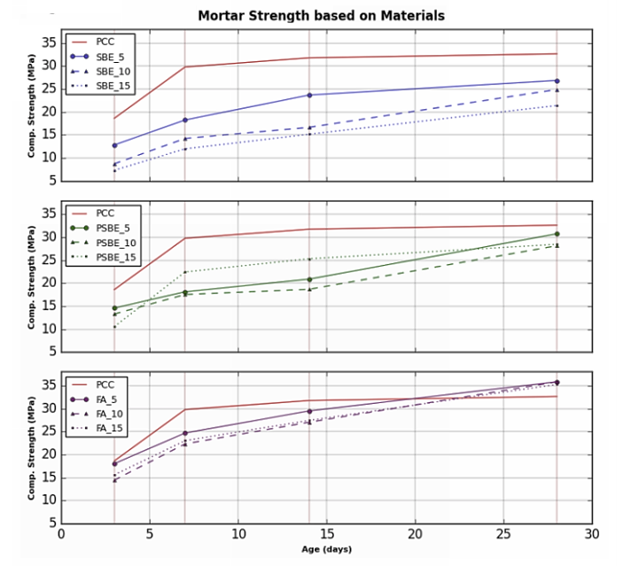

Figure 16. Individual Compression Strength Subplots

Upon analyzing both the overlaying compression strength plot in Figure 14 and the individual subplots in Figure 15, we can derive several conclusions.

Firstly, we can see the overall comparison of the material. It is evident from tendency displayed in Figure 14 that PCC has the highest compression strength, followed by fly ash, PSBE, and SBE in descending order.

Further analysis of the individual subplots in Figure 11 reveals that all PSBE samples, with the exception the 5% SBE mortar, exhibit superior performance compared to their SBE counterparts. Despite this improvement, PSBE performance still falls short when compared to the samples containing fly ash mixture. These finding suggest that PCC and fly ash are superior to PSBE in terms of compression strength.

However, there’s not yet a clear correlation between PSBE quantity with the optimum compression strength. The sample with lower quantity of PSBE presents the highest compression strength on the 3rd and 28th day, while samples with largest quantity of PSBE (15%) exhibits the highest strength on the 7th and 14th day.

The trend observed with fly ash confirms that despite having relatively low early strength, it surpasses other materials on the 28th day due to the impact of the Pozzolanic Reaction. This finding aligns with the research conducted by Wang & Song [12], which also demonstrated that fly ash gains strength over time.

Meanwhile, the unexpected observation of PSBE suggests that the effect of PSBE on the mortar strength may be influence by other factors. Therefore, further research is needed to determine the precise relationship between PSBE quantity and the compression strength.

SUMMARY

In conclusion, It would be more advantageous to treat SBE before utilization, as the reduced oil content significantly enhances the performance of the materials.

However, these are several effects that is caused by PSBE addition:

1. Delayed/Prolonged setting time.
2. Increased in water requirement.
3. Paste Strength Reduction.
4. Decreased of mortar’s workability.
5. Disruption of cement hydration.
6. Lowered mortar strength, particularly on the 28th day.

Based on these effects, it is noticeable that PSBE seems to have a rather negative impact on the overall performance of both cement paste and mortars. Therefore, the usage of PSBE as a cement substitute should be approached with caution.

REFERENCE

[1] S. M. Abdelbasir, A. I. Shehab, and M. A. A. Khalek, “Spent bleaching earth; recycling and utilization techniques: A review,” *Resources, Conservation & Recycling Advances*, vol. 17, p. 200124, May 2023, doi: 10.1016/j.rcradv.2022.200124.

[2] A. A. Al-Zahrani and M. A. Daous, “Recycling of Spent Bleaching Clay and Oil Recovery,” *Process Safety and Environmental Protection*, vol. 78, no. 3, pp. 224–228, May 2000, doi: 10.1205/095758200530682.

[3] L.-H. Wang and C.-I. Lin, “Kinetics of Heat Regeneration of Spent Bleaching Clay,” *Journal of Chemical Engineering of Japan*, vol. 33, no. 3, pp. 522–525, 2000, doi: 10.1252/jcej.33.522.

[4] A. Merikhy, A. Heydari, H. Eskandari, and A. Nematollahzadeh, “Revalorization of Spent Bleaching Earth a Waste from Vegetable Oil Refinery Plant by an Efficient Solvent Extraction System,” *Waste Biomass Valor*, vol. 10, no. 10, pp. 3045–3055, Oct. 2019, doi: 10.1007/s12649-018-0311-0.

[5] A. Kalam and J. B. Joshi, “Regeneration of spent earth in aqueous medium,” *J Am Oil Chem Soc*, vol. 65, no. 12, pp. 1917–1921, Dec. 1988, doi: 10.1007/BF02546007.

[6] D. A. Morgott, “Acetone,” in *Patty’s Toxicology*, John Wiley & Sons, Ltd, 2001. doi: 10.1002/0471435139.tox074.

[7] A. Reissell, C. Harry, S. M. Aschmann, R. Atkinson, and J. Arey, “Formation of acetone from the OH radical- and O 3 -initiated reactions of a series of monoterpenes,” *J. Geophys. Res.*, vol. 104, no. D11, pp. 13869–13879, Jun. 1999, doi: 10.1029/1999JD900198.

[8] M. Kosior-Kazberuk and M. Lelusz, “STRENGTH DEVELOPMENT OF CONCRETE WITH FLY ASH ADDITION,” *JOURNAL OF CIVIL ENGINEERING AND MANAGEMENT*, vol. 13, no. 2, pp. 115–122, Jun. 2007, doi: 10.3846/13923730.2007.9636427.

[9] S. C. K. Bendapudi and P. Saha, “Contribution of Fly ash to the properties of Mortar and Concrete,” *International Journal of Earth Sciences and Engineering*, vol. 04, no. 06, 2011.

[10] S. Mukarjee, “Study on the physical and mechanical property of ordinary portland cement and fly ash paste,” *IJCSER*, vol. 2, no. 3, Feb. 2012, doi: 10.6088/ijcser.00202030003.

[11] Antoni, L. Chandra, and D. Hardjito, “The Impact of Using Fly Ash, Silica Fume and Calcium Carbonate on the Workability and Compressive Strength of Mortar,” *Procedia Engineering*, vol. 125, pp. 773–779, 2015, doi: 10.1016/j.proeng.2015.11.132.

[12] Z. Wang and Y. Song, “Adsorption properties of CFBC ash–cement pastes as compared with PCC fly ash–cement pastes,” *Int J Coal Sci Technol*, vol. 3, no. 1, pp. 62–67, Mar. 2016, doi: 10.1007/s40789-016-0103-8.